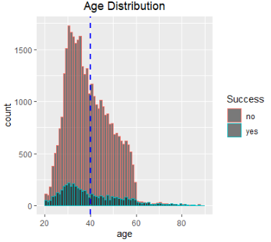
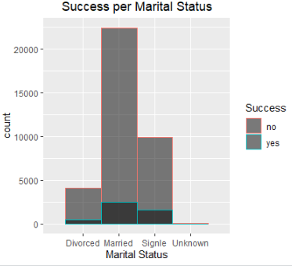
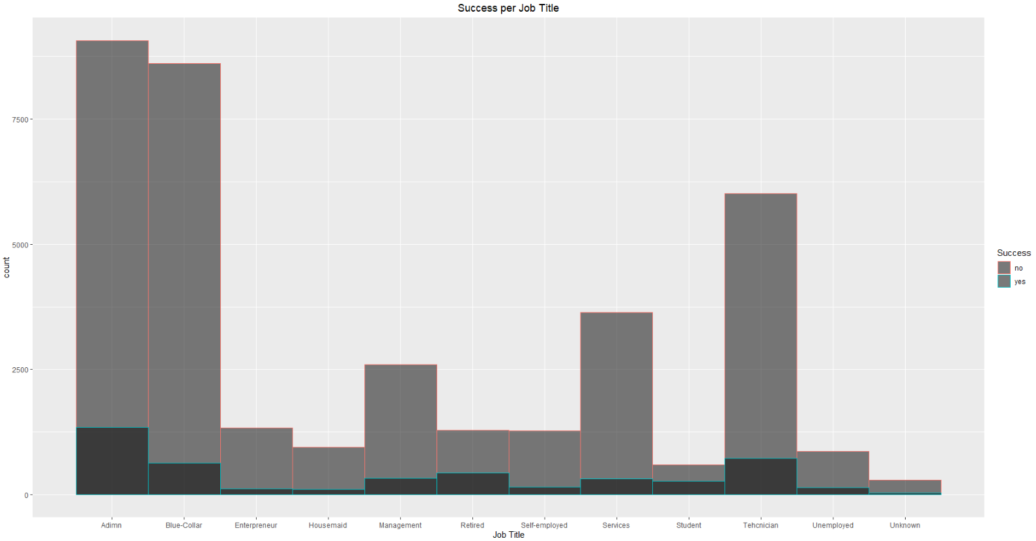
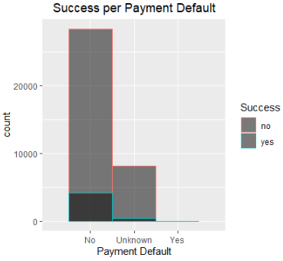
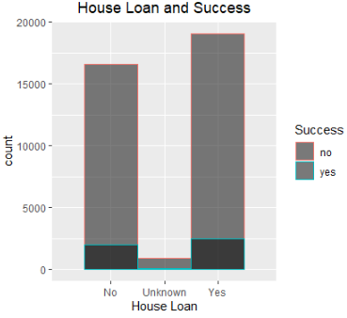

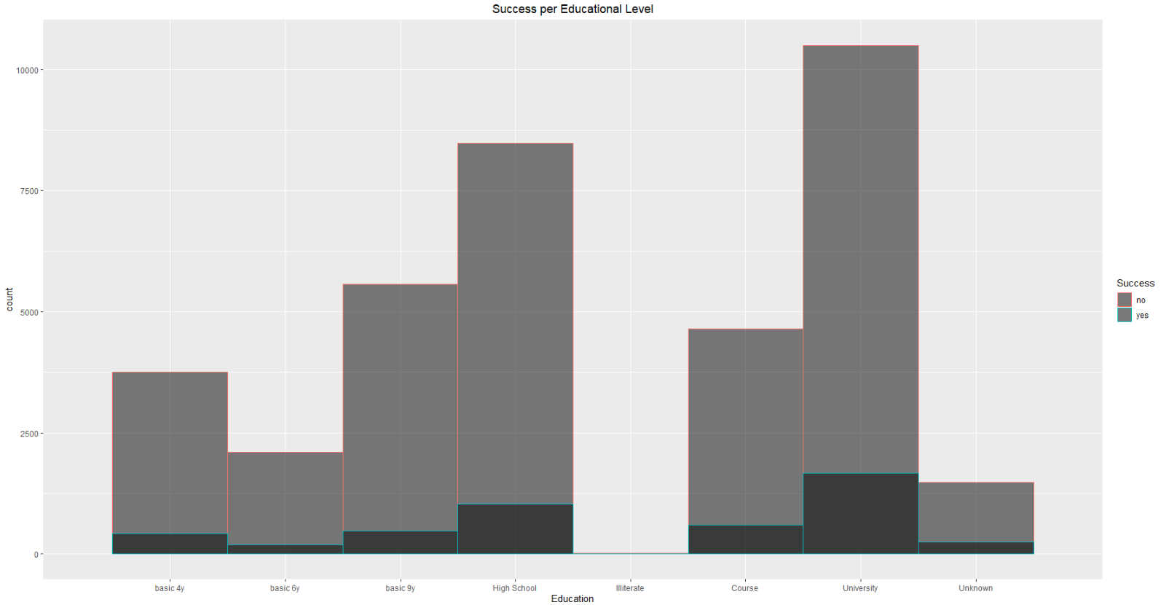
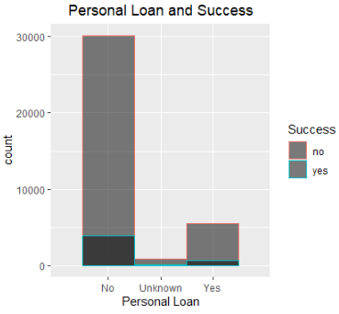
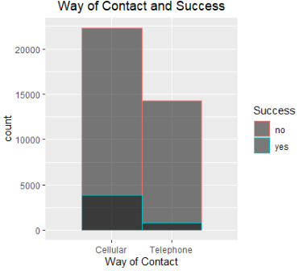
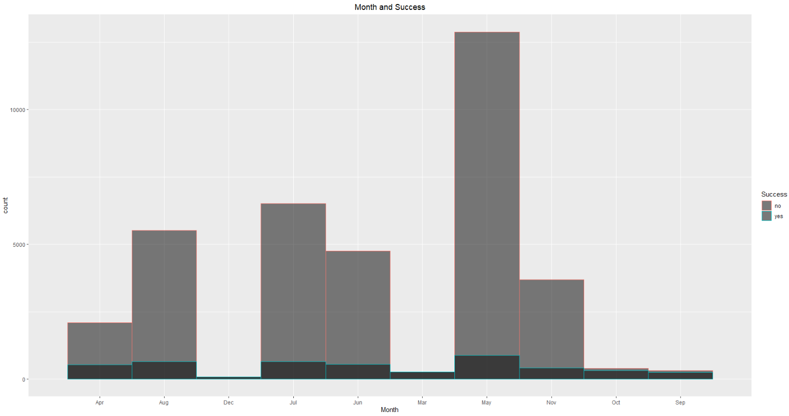

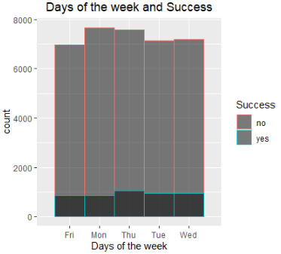
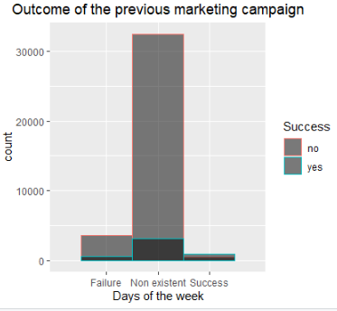

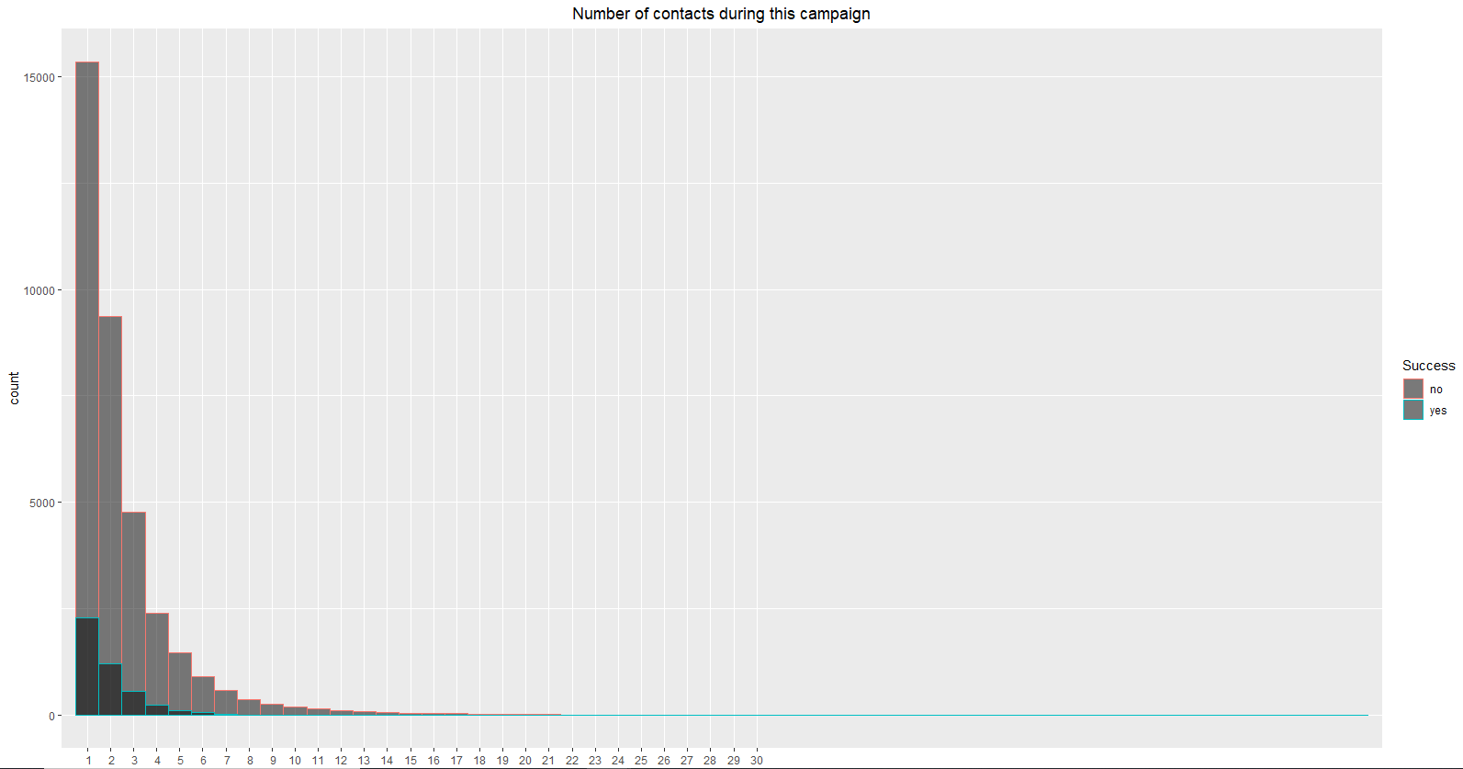
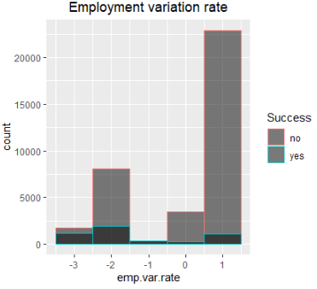
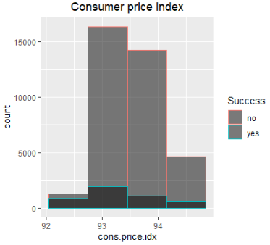

The correlation matrix on the right presents the variables with the highest correlation. It is important not to include highly correlated variables to the research question because we will cause overfitting. | 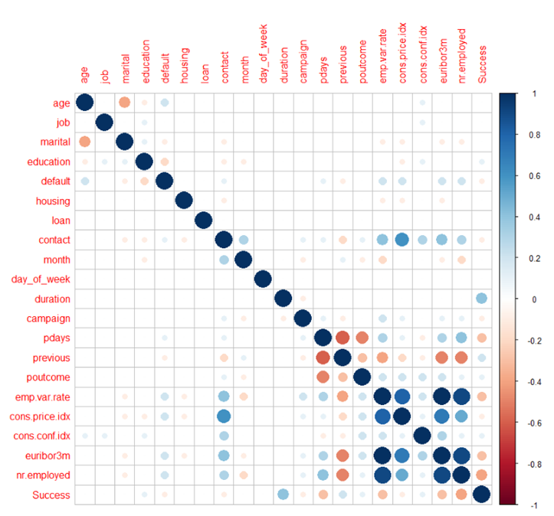

The variance plot presents how much of the total variance is covered by each PC. It is observed that the most PC covers almost half of the total variance. | 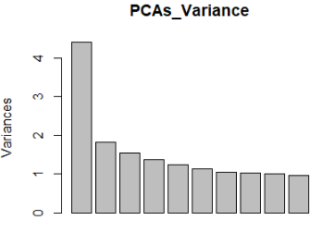
The cumulative PEV presents how the PCs contribute to cover the total of variance. A red line has been set at 80% of variance. All the PCs above this line will not be included in the analysis since they do not add significant value. | 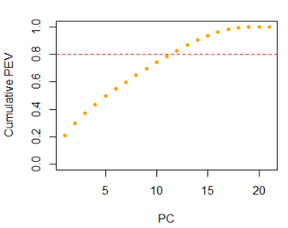

The first PC shows an early indication on how the variables interact to each other. For example, it can be observed that when the previous outcome goes up then the success goes up too meaning when for a customer the previous outcome was successful there is a highly probability that they will answer positively again. On the other hand, when the employment variation rate goes down the success go up meaning that it is more likely for a customer to answer positively if there are more employees. Finally, it is crucial to interpret the biplot according to the research question. | 